Introduction to Dimensionality Reduction
- Difficulty Level : Easy
- Last Updated : 27 Sep, 2022
- Read
- Discuss
Machine Learning: As discussed in this article, machine learning is nothing but a field of study which allows computers to “learn” like humans without any need of explicit programming.
What is Predictive Modeling: Predictive modeling is a probabilistic process that allows us to forecast outcomes, on the basis of some predictors. These predictors are basically features that come into play when deciding the final result, i.e. the outcome of the model.

What is Dimensionality Reduction?
In machine learning classification problems, there are often too many factors on the basis of which the final classification is done. These factors are basically variables called features. The higher the number of features, the harder it gets to visualize the training set and then work on it. Sometimes, most of these features are correlated, and hence redundant. This is where dimensionality reduction algorithms come into play. Dimensionality reduction is the process of reducing the number of random variables under consideration, by obtaining a set of principal variables. It can be divided into feature selection and feature extraction.

Why is Dimensionality Reduction important in Machine Learning and Predictive Modeling?
An intuitive example of dimensionality reduction can be discussed through a simple e-mail classification problem, where we need to classify whether the e-mail is spam or not. This can involve a large number of features, such as whether or not the e-mail has a generic title, the content of the e-mail, whether the e-mail uses a template, etc. However, some of these features may overlap. In another condition, a classification problem that relies on both humidity and rainfall can be collapsed into just one underlying feature, since both of the aforementioned are correlated to a high degree. Hence, we can reduce the number of features in such problems. A 3-D classification problem can be hard to visualize, whereas a 2-D one can be mapped to a simple 2 dimensional space, and a 1-D problem to a simple line. The below figure illustrates this concept, where a 3-D feature space is split into two 2-D feature spaces, and later, if found to be correlated, the number of features can be reduced even further.
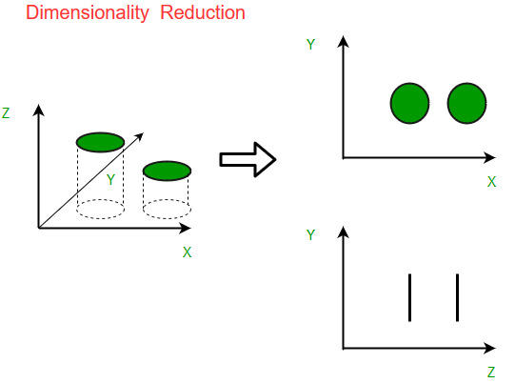
Components of Dimensionality Reduction
There are two components of dimensionality reduction:
- Feature selection: In this, we try to find a subset of the original set of variables, or features, to get a smaller subset which can be used to model the problem. It usually involves three ways:
  - Filter
  - Wrapper
  - Embedded
- Feature extraction: This reduces the data in a high dimensional space to a lower dimension space, i.e. a space with lesser no. of dimensions.

Methods of Dimensionality Reduction
The various methods used for dimensionality reduction include:
- Principal Component Analysis (PCA)
- Linear Discriminant Analysis (LDA)
- Generalized Discriminant Analysis (GDA)
Dimensionality reduction may be both linear or non-linear, depending upon the method used. The prime linear method, called Principal Component Analysis, or PCA, is discussed below.

Principal Component Analysis
This method was introduced by Karl Pearson. It works on a condition that while the data in a higher dimensional space is mapped to data in a lower dimension space, the variance of the data in the lower dimensional space should be maximum. 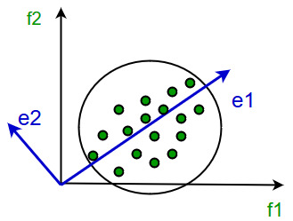 It involves the following steps:
- Construct the covariance matrix of the data.
- Compute the eigenvectors of this matrix.
- Eigenvectors corresponding to the largest eigenvalues are used to reconstruct a large fraction of variance of the original data.
Hence, we are left with a lesser number of eigenvectors, and there might have been some data loss in the process. But, the most important variances should be retained by the remaining eigenvectors.
Advantages of Dimensionality Reduction
- It helps in data compression, and hence reduced storage space.
- It reduces computation time.
- It also helps remove redundant features, if any.
Disadvantages of Dimensionality Reduction
- It may lead to some amount of data loss.
- PCA tends to find linear correlations between variables, which is sometimes undesirable.
- PCA fails in cases where mean and covariance are not enough to define datasets.
- We may not know how many principal components to keep- in practice, some thumb rules are applied.
This article is contributed by Anannya Uberoi. If you like GeeksforGeeks and would like to contribute, you can also write an article using write.geeksforgeeks.org or mail your article to review-team@geeksforgeeks.org. See your article appearing on the GeeksforGeeks main page and help other Geeks.
Please write comments if you find anything incorrect, or you want to share more information about the topic discussed above.

Previous
Parameters for Feature Selection
Next
ML | Underfitting and Overfitting
Recommended Articles
Page :
1
2
3
Reduce Data Dimensionality using PCA - Python
01, Mar 22
Propositional Logic Reduction
26, Feb 22
Introduction to Artificial Neutral Networks | Set 1
21, Jan 18
Introduction to Artificial Neural Network | Set 2
28, Jan 18
Introduction to Deep Learning
01, Jun 18
Introduction to Stemming
20, Jun 18
Introduction to Multi-Task Learning(MTL) for Deep Learning
14, Nov 18
Introduction to Natural Language Processing
16, Nov 18
Introduction to Bootstrap plot
07, Mar 21
Deep Learning | Introduction to Long Short Term Memory
16, Jan 19
Deep Learning with PyTorch | An Introduction
06, Feb 19
ML | Momentum-based Gradient Optimizer introduction
15, Feb 19
CNN | Introduction to Padding
23, Jul 19
ML | Introduction to Kernel PCA
19, Aug 19
Introduction to Thompson Sampling | Reinforcement Learning
22, Aug 19
ML | Introduction to Strided Convolutions
18, Nov 19
Neural Logic Reinforcement Learning - An Introduction
12, Jan 20
Introduction to Residual Networks
10, Jan 20
Introduction to Predictive Maintenance
10, Feb 20
Introduction to Ontologies
19, Feb 20
Introduction to Ant Colony Optimization
15, May 20
Introduction to Quantum Machine Learning
10, Jul 20
An introduction to MultiLabel classification
15, Jul 20
Introduction to Concept Drift
25, Jul 20
Article Contributed By :

GeeksforGeeks
Vote for difficulty
Current difficulty : Easy
Improved By :
- img201d8rw
Article Tags :
- Machine Learning
Practice Tags :
- Machine Learning

Report Issue

Data Structures & Algorithms- Self Paced Course
View Details
AD

AD

What's New


Machine Learning Foundation - Self Paced
View Details

Complete Interview Preparation- Self Paced Course
View Details

AD

AD

AD

ML | Introduction to Kernel PCA
- Difficulty Level : Medium
- Last Updated : 26 Aug, 2019
- Read
- Discuss
PRINCIPAL COMPONENT ANALYSIS: is a tool which is used to reduce the dimension of the data. It allows us to reduce the dimension of the data without much loss of information. PCA reduces the dimension by finding a few orthogonal linear combinations (principal components) of the original variables with the largest variance.
The first principal component captures most of the variance in the data. The second principal component is orthogonal to the first principal component and captures the remaining variance, which is left of first principal component and so on. There are as many principal components as the number of original variables.
These principal components are uncorrelated and are ordered in such a way that the first several principal components explain most of the variance of the original data. To learn more about PCA you can read the article Principal Component Analysis
KERNEL PCA:

PCA is a linear method. That is it can only be applied to datasets which are linearly separable. It does an excellent job for datasets, which are linearly separable. But, if we use it to non-linear datasets, we might get a result which may not be the optimal dimensionality reduction. Kernel PCA uses a kernel function to project dataset into a higher dimensional feature space, where it is linearly separable. It is similar to the idea of Support Vector Machines.
There are various kernel methods like linear, polynomial, and gaussian.

Code: Create a dataset which is nonlinear and then apply PCA on the dataset.
import matplotlib.pyplot as plt
from sklearn.datasets import make_moons

X, y = make_moons(n_samples = 500, noise = 0.02, random_state = 417)

plt.scatter(X[:, 0], X[:, 1], c = y)
plt.show()

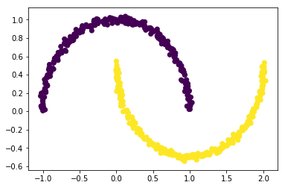
Code: Let’s apply PCA on this dataset
from sklearn.decomposition import PCA
pca = PCA(n_components = 2)
X_pca = pca.fit_transform(X)

plt.title("PCA")
plt.scatter(X_pca[:, 0], X_pca[:, 1], c = y)
plt.xlabel("Component 1")
plt.ylabel("Component 2")
plt.show()

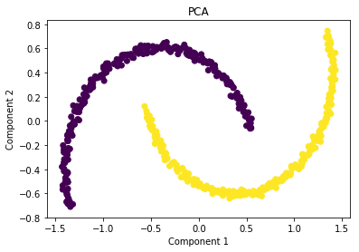
As you can see PCA failed to distinguish the two classes.
Code: Applying kernel PCA on this dataset with RBF kernel with a gamma value of 15.
from sklearn.decomposition import KernelPCA
kpca = KernelPCA(kernel ='rbf', gamma = 15)
X_kpca = kpca.fit_transform(X)

plt.title("Kernel PCA")
plt.scatter(X_kpca[:, 0], X_kpca[:, 1], c = y)
plt.show()

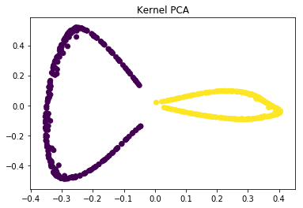
In the kernel space the two classes are linearly separable. Kernel PCA uses a kernel function to project the dataset into a higher-dimensional space, where it is linearly separable.
Finally, we applied the kernel PCA to a non-linear dataset using scikit-learn.
References:
https://en.wikipedia.org/wiki/Kernel_principal_component_analysis
http://fourier.eng.hmc.edu/e161/lectures/kernelPCA/node4.html

ML | Principal Component Analysis(PCA)
- Difficulty Level : Medium
- Last Updated : 20 Jul, 2021
- Read
- Discuss
Principal Component Analysis (PCA) is a statistical procedure that uses an orthogonal transformation that converts a set of correlated variables to a set of uncorrelated variables. PCA is the most widely used tool in exploratory data analysis and in machine learning for predictive models. Moreover, PCA is an unsupervised statistical technique used to examine the interrelations among a set of variables. It is also known as a general factor analysis where regression determines a line of best fit.
Module Needed:

import pandas as pd
import numpy as np
import matplotlib.pyplot as plt
import seaborn as sns
%matplotlib inline

Code #1:
# Here we are using inbuilt dataset of scikit learn
from sklearn.datasets import load_breast_cancer

# instantiating
cancer = load_breast_cancer()

# creating dataframe
df = pd.DataFrame(cancer['data'], columns = cancer['feature_names'])

# checking head of dataframe
df.head()

Output:
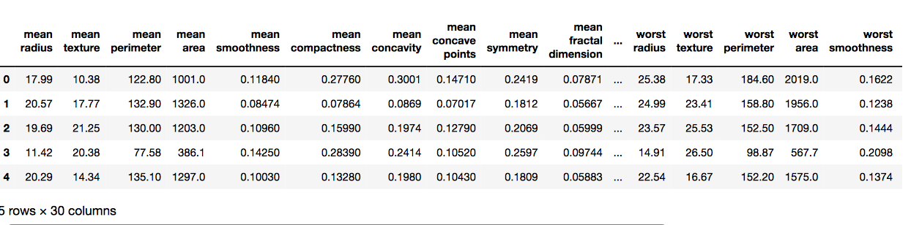
Code #2:

# Importing standardscalar module
from sklearn.preprocessing import StandardScaler

scalar = StandardScaler()

# fitting
scalar.fit(df)
scaled_data = scalar.transform(df)

# Importing PCA
from sklearn.decomposition import PCA

# Let's say, components = 2
pca = PCA(n_components = 2)
pca.fit(scaled_data)
x_pca = pca.transform(scaled_data)

x_pca.shape

Output:
569, 2
# giving a larger plot
plt.figure(figsize =(8, 6))

plt.scatter(x_pca[:, 0], x_pca[:, 1], c = cancer['target'], cmap ='plasma')

# labeling x and y axes
plt.xlabel('First Principal Component')
plt.ylabel('Second Principal Component')

Output:
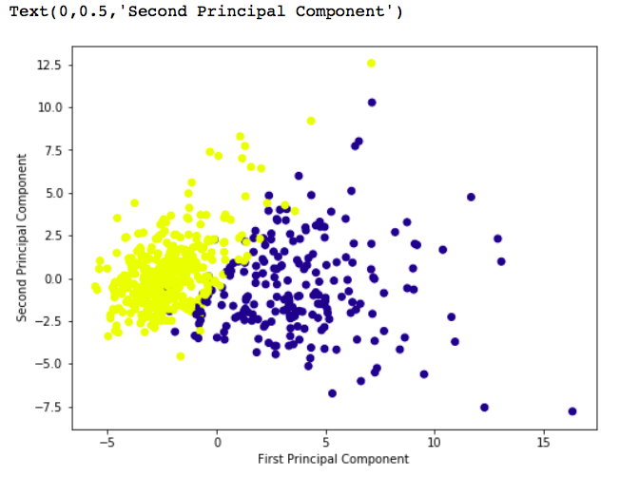
# components
pca.components_

Output:
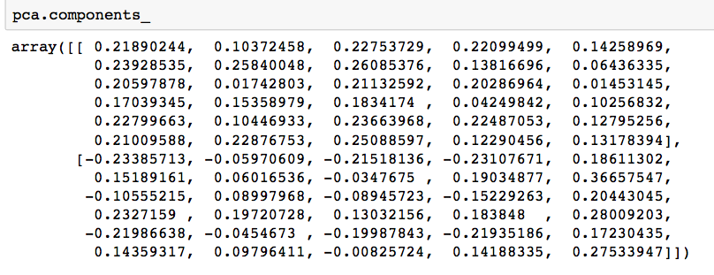

df_comp = pd.DataFrame(pca.components_, columns = cancer['feature_names'])

plt.figure(figsize =(14, 6))

# plotting heatmap
sns.heatmap(df_comp)

Output:
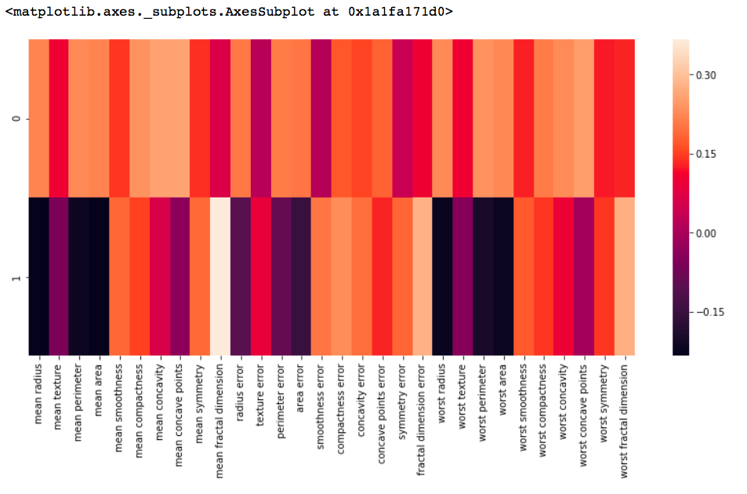

Principal Component Analysis with Python
- Difficulty Level : Easy
- Last Updated : 24 Aug, 2022
- Read
- Discuss
Principal Component Analysis is basically a statistical procedure to convert a set of observations of possibly correlated variables into a set of values of linearly uncorrelated variables.
Each of the principal components is chosen in such a way so that it would describe most of them still available variance and all these principal components are orthogonal to each other. In all principal components first principal component has a maximum variance.
Uses of PCA:
- It is used to find inter-relation between variables in the data.
- It is used to interpret and visualize data.
- The number of variables is decreasing it makes further analysis simpler.
- It’s often used to visualize genetic distance and relatedness between populations.
These are basically performed on a square symmetric matrix. It can be a pure sums of squares and cross-products matrix or Covariance matrix or Correlation matrix. A correlation matrix is used if the individual variance differs much.
Objectives of PCA:
- It is basically a non-dependent procedure in which it reduces attribute space from a large number of variables to a smaller number of factors.
- PCA is basically a dimension reduction process but there is no guarantee that the dimension is interpretable.
- The main task in this PCA is to select a subset of variables from a larger set, based on which original variables have the highest correlation with the principal amount.
Principal Axis Method: PCA basically searches a linear combination of variables so that we can extract maximum variance from the variables. Once this process completes it removes it and searches for another linear combination that gives an explanation about the maximum proportion of remaining variance which basically leads to orthogonal factors. In this method, we analyze total variance.
Eigenvector: It is a non-zero vector that stays parallel after matrix multiplication. Let’s suppose x is an eigenvector of dimension r of matrix M with dimension r*r if Mx and x are parallel. Then we need to solve Mx=Ax where both x and A are unknown to get eigenvector and eigenvalues.
Under Eigen-Vectors we can say that Principal components show both common and unique variance of the variable. Basically, it is variance focused approach seeking to reproduce total variance and correlation with all components. The principal components are basically the linear combinations of the original variables weighted by their contribution to explain the variance in a particular orthogonal dimension.
Eigen Values: It is basically known as characteristic roots. It basically measures the variance in all variables which is accounted for by that factor. The ratio of eigenvalues is the ratio of explanatory importance of the factors with respect to the variables. If the factor is low then it is contributing less to the explanation of variables. In simple words, it measures the amount of variance in the total given database accounted by the factor. We can calculate the factor’s eigenvalue as the sum of its squared factor loading for all the variables.
Now, Let’s understand Principal Component Analysis with Python.
To get the dataset used in the implementation, click here.
Step 1: Importing the libraries

# importing required libraries
import numpy as np
import matplotlib.pyplot as plt
import pandas as pd

Step 2: Importing the data set
Import the dataset and distributing the dataset into X and y components for data analysis.

# importing or loading the dataset
dataset = pd.read_csv('wine.csv')

# distributing the dataset into two components X and Y
X = dataset.iloc[:, 0:13].values
y = dataset.iloc[:, 13].values

Step 3: Splitting the dataset into the Training set and Test set

# Splitting the X and Y into the
# Training set and Testing set
from sklearn.model_selection import train_test_split

X_train, X_test, y_train, y_test = train_test_split(X, y, test_size = 0.2, random_state = 0)

Step 4: Feature Scaling
Doing the pre-processing part on training and testing set such as fitting the Standard scale.

# performing preprocessing part
from sklearn.preprocessing import StandardScaler
sc = StandardScaler()

X_train = sc.fit_transform(X_train)
X_test = sc.transform(X_test)

Step 5: Applying PCA function
Applying the PCA function into the training and testing set for analysis.

# Applying PCA function on training
# and testing set of X component
from sklearn.decomposition import PCA

pca = PCA(n_components = 2)

X_train = pca.fit_transform(X_train)
X_test = pca.transform(X_test)

explained_variance = pca.explained_variance_ratio_

Step 6: Fitting Logistic Regression To the training set

# Fitting Logistic Regression To the training set
from sklearn.linear_model import LogisticRegression

classifier = LogisticRegression(random_state = 0)
classifier.fit(X_train, y_train)

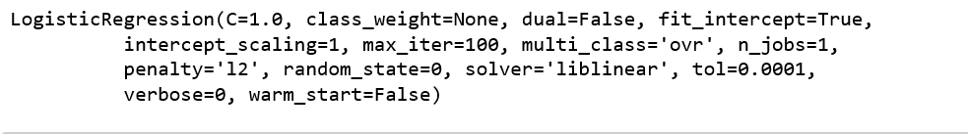
Step 7: Predicting the test set result

# Predicting the test set result using
# predict function under LogisticRegression
y_pred = classifier.predict(X_test)

Step 8: Making the confusion matrix

# making confusion matrix between
# test set of Y and predicted value.
from sklearn.metrics import confusion_matrix

cm = confusion_matrix(y_test, y_pred)

Step 9: Predicting the training set result

# Predicting the training set
# result through scatter plot
from matplotlib.colors import ListedColormap

X_set, y_set = X_train, y_train
X1, X2 = np.meshgrid(np.arange(start = X_set[:, 0].min() - 1,
stop = X_set[:, 0].max() + 1, step = 0.01),
np.arange(start = X_set[:, 1].min() - 1,
stop = X_set[:, 1].max() + 1, step = 0.01))

plt.contourf(X1, X2, classifier.predict(np.array([X1.ravel(),
X2.ravel()]).T).reshape(X1.shape), alpha = 0.75,
cmap = ListedColormap(('yellow', 'white', 'aquamarine')))

plt.xlim(X1.min(), X1.max())
plt.ylim(X2.min(), X2.max())

for i, j in enumerate(np.unique(y_set)):
plt.scatter(X_set[y_set == j, 0], X_set[y_set == j, 1],
c = ListedColormap(('red', 'green', 'blue'))(i), label = j)

plt.title('Logistic Regression (Training set)')
plt.xlabel('PC1') # for Xlabel
plt.ylabel('PC2') # for Ylabel
plt.legend() # to show legend

# show scatter plot
plt.show()

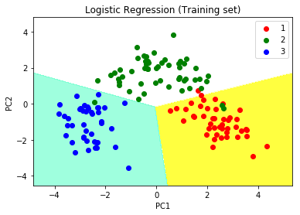
Step 10: Visualizing the Test set results

# Visualising the Test set results through scatter plot
from matplotlib.colors import ListedColormap

X_set, y_set = X_test, y_test

X1, X2 = np.meshgrid(np.arange(start = X_set[:, 0].min() - 1,
stop = X_set[:, 0].max() + 1, step = 0.01),
np.arange(start = X_set[:, 1].min() - 1,
stop = X_set[:, 1].max() + 1, step = 0.01))

plt.contourf(X1, X2, classifier.predict(np.array([X1.ravel(),
X2.ravel()]).T).reshape(X1.shape), alpha = 0.75,
cmap = ListedColormap(('yellow', 'white', 'aquamarine')))

plt.xlim(X1.min(), X1.max())
plt.ylim(X2.min(), X2.max())

for i, j in enumerate(np.unique(y_set)):
plt.scatter(X_set[y_set == j, 0], X_set[y_set == j, 1],
c = ListedColormap(('red', 'green', 'blue'))(i), label = j)

# title for scatter plot
plt.title('Logistic Regression (Test set)')
plt.xlabel('PC1') # for Xlabel
plt.ylabel('PC2') # for Ylabel
plt.legend()

# show scatter plot
plt.show()

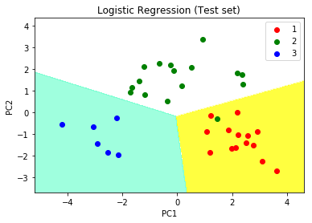

Eigenvector Computation and Low-Rank Approximations
- Last Updated : 30 May, 2021
- Read
- Discuss
Prerequisites: Eigen Values and Eigen Vectors
Before getting into the in-depth math behind computations involved with Eigenvectors, let us briefly discuss what an eigenvalue and eigenvector actually are.

Eigenvalue and Eigenvectors:
The word ‘eigen’ means ‘characteristics‘. In general terms, the eigenvalues and eigenvectors give the characteristics of a matrix or a vector.
Eigenvector: It is a vector represented by a matrix X such that when X is multiplied with any matrix A, then the direction of the resultant matrix remains the same as vector X. Observe Fig 1 carefully to look at a graphical representation of an eigenvector.

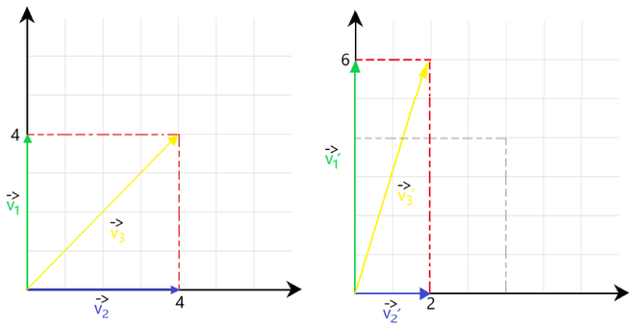
Fig 1 : Eigenvector representation
In Fig 1, we observe the following scalar transformations:
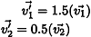
After applying these transformations, the vectors v1‘ and v2‘ are in the same direction as v1 and v2. So as per our definition, these are considered as eigenvectors. But resultant vector v3‘ is not in the same direction as v3. Hence it cannot be considered as a eigenvector.
Eigenvalues: It tells us about the extent to which the eigenvector has been stretched or diminished.
In the above case, the eigenvalues will be 1.5 and 0.5.

Computing Eigenvectors
We can calculate eigenvalues of any matrix using the characteristic equation of the matrix (as discussed in the prerequisite article) that is:
The roots of the above equation (i.e. values of λ) gives us the eigenvalues.
Using the values of λ obtained, we can find the corresponding eigenvectors using the equation given below.
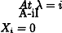

Example Problem
Consider the following example for a better understanding. Let there be a 3×3 matrix X defined as:
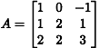
Find the eigen values and eigen vectors corresponding to the matrix A.

Solution
1. Finding the eigen values.
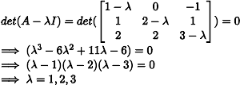
Thus, the eigen values obtained are 1, 2 and 3.
2. Finding the eigen vectors.
Using the formula given above, we will calculate a corresponding eigen vector xi for each value of λi.
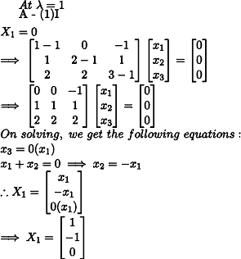

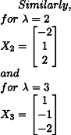
Thus, we obtain the eigen vectors X1, X2, X3 corresponding to each value of λ.

Rank of a matrix:
Rank of a (m x n) matrix is determined by the number of linearly independent rows present in the matrix. Consider the example given below for a better understanding.
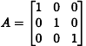
All 3 rows of matrix A are linearly independent. Therefore, Rank ( A ) = 3.
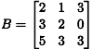
Rank ( B ) = 2. This is because Row 3 is dependent on R1 and R2. [R3 <- R1 + R2]

Some important properties:
For any matrix A of shape m x n, the following rank properties are applicable:
- Rank (A) = Rank (AT)
- Rank (BAC) = Rank (A) provided B and C are invertible matrices.
- Rank (AB) ≤ min{ Rank (A) + Rank (B) }
Before getting into Low-Rank Approximation, it is important to understand the following:
- Matrix Factorization
Any matrix A of shape m x n having rank (A) = r is said to be factorized when it takes the form:

where, the shapes of the matrices are:

mat(A) -> m x n
mat(B) -> m x r
mat(C) -> n x r
- Low Rank
We say that matrix A has a low rank if r << min {m,n}.

Low Rank Approximation (LRA)
Based on the above two discussed method, we define LRA as:
For a matrix A of shape m x n and rank (A) << min {m, n}, the low-rank approximation of A is to find another matrix B such that rank (B) ≤ rank (A). Intuitively, we tend to see how linearly similar matrix B is to the input matrix A. Mathematically, LRA is a minimization problem, in which we measure the fit between a given matrix (the data) and an approximating matrix (the optimization variable).

Motivation for LRA
Let us assume 3 matrices X, Y, Z of dimensions (50 x 40), (50 x 10), (40 x 10) respectively where rank(X) = 10. Therefore, as per matrix factorization, the three matrices are of the form A = BCT. We observe that:
Amxn = BmxrCTrxn

No of elements/pixels in mat(A) = (50 x 40) = 2000
while
No of elements/pixels in mat(BCT) = (50 x 10) + (10 x 40) = 900.
Thus, by using low-rank approximation, we can reduce the number of pixels of input data by a significant amount. (1100 fewer pixels than input image in the above case)

Application of LRA
This method is commonly used in Image Processing tasks where the input image (data) is very large and needs to be compressed before any processing task. Observe the two images of the same person given below.

After LRA image vs Input image
After applying LRA, we are able to obtain an image that is very similar to the original image by discarding some unimportant pixels, hence reducing the size of the image as well. After doing this, it becomes much easier to handle such large datasets and perform a variety of pre-processing tasks on them.

Previous
N-Gram Language Modelling with NLTK
Next
Problem solving on Boolean Model and Vector Space Model
Recommended Articles
Page :
1
2
3
Need of Data Structures and Algorithms for Deep Learning and Machine Learning
14, Oct 20
Black and white image colorization with OpenCV and Deep Learning
05, Mar 22
Interquartile Range and Quartile Deviation using NumPy and SciPy
13, Jun 19
Hyperparameter tuning using GridSearchCV and KerasClassifier
25, Nov 20
Python | How and where to apply Feature Scaling?
17, Jun 18
Difference between Supervised and Unsupervised Learning
19, Jun 18
Python | Tensorflow nn.relu() and nn.leaky_relu()
13, Sep 18
Redundancy and Correlation in Data Mining
13, Jun 19
Box plot and Histogram exploration on Iris data
18, Jan 19
NLP | Training a tokenizer and filtering stopwords in a sentence
28, Jan 19
NLP | Splitting and Merging Chunks
28, Jan 19
NLP | Regex and Affix tagging
21, Feb 19
Deep Neural net with forward and back propagation from scratch - Python
07, Jun 20
KDE Plot Visualization with Pandas and Seaborn
02, May 19
Boosting in Machine Learning | Boosting and AdaBoost
03, May 19
Dunn index and DB index - Cluster Validity indices | Set 1
09, May 19
ML | Intercluster and Intracluster Distance
10, May 19
ML | DBSCAN reachability and connectivity
16, May 19
Absolute Deviation and Absolute Mean Deviation using NumPy | Python
20, May 19
Translation and Natural Language Processing using Google Cloud
22, May 19
Combining IoT and Machine Learning makes our future smarter
23, May 19
ML | Kaggle Breast Cancer Wisconsin Diagnosis using KNN and Cross Validation
04, Jun 19
ML | Implementing L1 and L2 regularization using Sklearn
11, Jun 19
NLP | How to score words with Execnet and Redis
17, Jun 19
Article Contributed By :

prakharr0y
@prakharr0y
Vote for difficulty
Article Tags :
- Machine Learning
Practice Tags :
- Machine Learning

Report Issue
Data Structures & Algorithms- Self Paced Course
View Details
AD

AD

What's New

Machine Learning Foundation - Self Paced
View Details
Complete Interview Preparation- Self Paced Course
View Details

AD

AD

AD

ML | Linear Discriminant Analysis
- Difficulty Level : Medium
- Last Updated : 24 Aug, 2022
- Read
- Discuss
Linear Discriminant Analysis or Normal Discriminant Analysis or Discriminant Function Analysis is a dimensionality reduction technique that is commonly used for supervised classification problems. It is used for modelling differences in groups i.e. separating two or more classes. It is used to project the features in higher dimension space into a lower dimension space.
For example, we have two classes and we need to separate them efficiently. Classes can have multiple features. Using only a single feature to classify them may result in some overlapping as shown in the below figure. So, we will keep on increasing the number of features for proper classification.
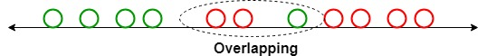
Example:
Suppose we have two sets of data points belonging to two different classes that we want to classify. As shown in the given 2D graph, when the data points are plotted on the 2D plane, there’s no straight line that can separate the two classes of the data points completely. Hence, in this case, LDA (Linear Discriminant Analysis) is used which reduces the 2D graph into a 1D graph in order to maximize the separability between the two classes.
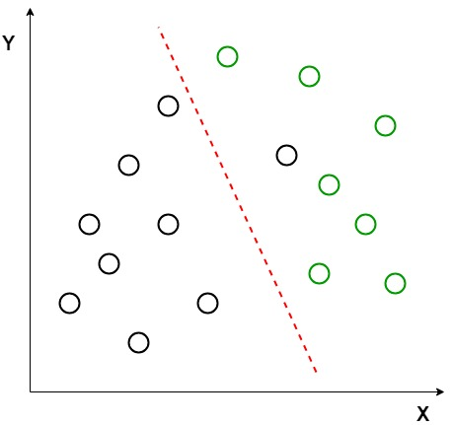
Here, Linear Discriminant Analysis uses both the axes (X and Y) to create a new axis and projects data onto a new axis in a way to maximize the separation of the two categories and hence, reducing the 2D graph into a 1D graph.
Two criteria are used by LDA to create a new axis:
- Maximize the distance between means of the two classes.
- Minimize the variation within each class.

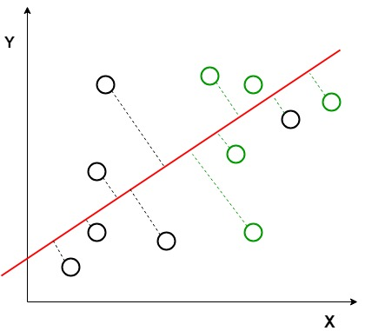
In the above graph, it can be seen that a new axis (in red) is generated and plotted in the 2D graph such that it maximizes the distance between the means of the two classes and minimizes the variation within each class. In simple terms, this newly generated axis increases the separation between the data points of the two classes. After generating this new axis using the above-mentioned criteria, all the data points of the classes are plotted on this new axis and are shown in the figure given below.
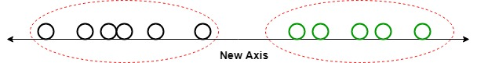
But Linear Discriminant Analysis fails when the mean of the distributions are shared, as it becomes impossible for LDA to find a new axis that makes both the classes linearly separable. In such cases, we use non-linear discriminant analysis.
Mathematics
Let’s suppose we have two classes and a d- dimensional samples such as x1, x2 … xn, where:
- n1 samples coming from the class (c1) and n2 coming from the class (c2).
If xi is the data point, then its projection on the line represented by unit vector v can be written as vTxi
Let’s consider u1 and u2 be the means of samples class c1 and c2 respectively before projection and u1hat denotes the mean of the samples of class after projection and it can be calculated by:
Similarly,
Now, In LDA we need to normalize |\widetilde{\mu_1} -\widetilde{\mu_2} |. Let y_i = v^{T}x_i be the projected samples, then scatter for the samples of c1 is:
Similarly:
Now, we need to project our data on the line having direction v which maximizes
For maximizing the above equation we need to find a projection vector that maximizes the difference of means of reduces the scatters of both classes. Now, scatter matrix of s1 and s2 of classes c1 and c2 are:
and s2
After simplifying the above equation, we get:
Now, we define, scatter within the classes(sw) and scatter b/w the classes(sb):
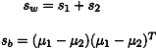
Now, we try to simplify the numerator part of J(v)
Now, To maximize the above equation we need to calculate differentiation with respect to v
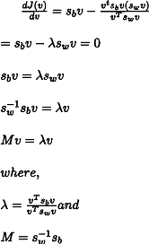
Here, for the maximum value of J(v) we will use the value corresponding to the highest eigenvalue. This will provide us the best solution for LDA.
Extensions to LDA:
- Quadratic Discriminant Analysis (QDA): Each class uses its own estimate of variance (or covariance when there are multiple input variables).
- Flexible Discriminant Analysis (FDA): Where non-linear combinations of inputs are used such as splines.
- Regularized Discriminant Analysis (RDA): Introduces regularization into the estimate of the variance (actually covariance), moderating the influence of different variables on LDA.
Implementation
- In this implementation, we will perform linear discriminant analysis using the Scikit-learn library on the Iris dataset.

# necessary import
import numpy as np
import pandas as pd
import matplotlib.pyplot as plt
import sklearn
from sklearn.preprocessing import StandardScaler, LabelEncoder
from sklearn.model_selection import train_test_split
from sklearn.discriminant_analysis import LinearDiscriminantAnalysis
from sklearn.ensemble import RandomForestClassifier
from sklearn.metrics import accuracy_score, confusion_matrix

# read dataset from URL
url = "https://archive.ics.uci.edu/ml/machine-learning-databases/iris/iris.data"
cls = ['sepal-length', 'sepal-width', 'petal-length', 'petal-width', 'Class']
dataset = pd.read_csv(url, names=cls)

# divide the dataset into class and target variable
X = dataset.iloc[:, 0:4].values
y = dataset.iloc[:, 4].values

# Preprocess the dataset and divide into train and test
sc = StandardScaler()
X = sc.fit_transform(X)
le = LabelEncoder()
y = le.fit_transform(y)
X_train, X_test, y_train, y_test = train_test_split(X, y, test_size=0.2)

# apply Linear Discriminant Analysis
lda = LinearDiscriminantAnalysis(n_components=2)
X_train = lda.fit_transform(X_train, y_train)
X_test = lda.transform(X_test)

# plot the scatterplot
plt.scatter(
X_train[:,0],X_train[:,1],c=y_train,cmap='rainbow',
alpha=0.7,edgecolors='b'
)

# classify using random forest classifier
classifier = RandomForestClassifier(max_depth=2, random_state=0)
classifier.fit(X_train, y_train)
y_pred = classifier.predict(X_test)

# print the accuracy and confusion matrix
print('Accuracy : ' + str(accuracy_score(y_test, y_pred)))
conf_m = confusion_matrix(y_test, y_pred)
print(conf_m)

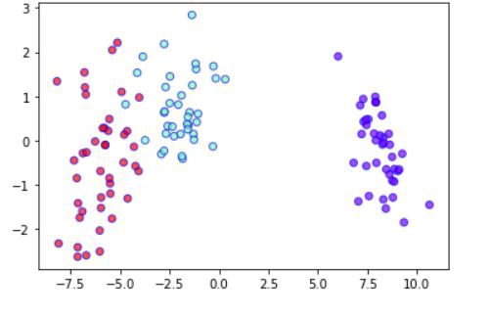
LDA 2 -variable plot
Accuracy : 0.9

[[10 0 0]
[ 0 9 3]
[ 0 0 8]]
Applications:
- Face Recognition: In the field of Computer Vision, face recognition is a very popular application in which each face is represented by a very large number of pixel values. Linear discriminant analysis (LDA) is used here to reduce the number of features to a more manageable number before the process of classification. Each of the new dimensions generated is a linear combination of pixel values, which form a template. The linear combinations obtained using Fisher’s linear discriminant are called Fisher’s faces.
- Medical: In this field, Linear discriminant analysis (LDA) is used to classify the patient disease state as mild, moderate, or severe based upon the patient’s various parameters and the medical treatment he is going through. This helps the doctors to intensify or reduce the pace of their treatment.
- Customer Identification: Suppose we want to identify the type of customers who are most likely to buy a particular product in a shopping mall. By doing a simple question and answers survey, we can gather all the features of the customers. Here, a Linear discriminant analysis will help us to identify and select the features which can describe the characteristics of the group of customers that are most likely to buy that particular product in the shopping mall.

Next
ML | Principal Component Analysis(PCA)
Recommended Articles
Page :
1
2
3
Gaussian Discriminant Analysis
07, Dec 20
Regularized Discriminant Analysis
27, May 21
Quadratic Discriminant Analysis
18, Jul 21
Analysis of test data using K-Means Clustering in Python
07, Jan 18
ML | Principal Component Analysis(PCA)
07, Jul 18
Python | NLP analysis of Restaurant reviews
05, Sep 18
Multidimensional data analysis in Python
29, Oct 18
Exploratory Data Analysis in Python | Set 1
18, Jan 19
Exploratory Data Analysis in Python | Set 2
18, Jan 19
Fine-tuning BERT model for Sentiment Analysis
01, Mar 22
ML | Independent Component Analysis
21, May 19
Heteroscedasticity in Regression Analysis
06, Jun 19
Data Analysis with SciPy
26, Jun 19
ML | Adjusted R-Square in Regression Analysis
27, Jun 19
Python | CAP - Cumulative Accuracy Profile analysis
07, Aug 19
Python | Customer Churn Analysis Prediction
22, Mar 20
Step by Step Predictive Analysis - Machine Learning
17, Mar 20
Analysis required in Natural Language Generation (NLG) and Understanding (NLU)
06, May 20
What is Sentiment Analysis?
10, Jul 20
Conceptual Framework for Solving Data Analysis Problems
16, Jul 20
Python - Variations of Principal Component Analysis
04, Jun 20
Text Analysis Using Turicreate
29, Aug 20
Aspect Modelling in Sentiment Analysis
30, May 21
Covid-19 Data Analysis Using Tableau
20, Jan 21
Article Contributed By :

raman_257
@raman_257
Vote for difficulty
Current difficulty : Medium
Improved By :
- pawangfg
- 23603vaibhav2021
Article Tags :
- Machine Learning
Practice Tags :
- Machine Learning

Report Issue
Data Structures & Algorithms- Self Paced Course
View Details
AD

AD

What's New

Machine Learning Foundation - Self Paced
View Details
Complete Interview Preparation- Self Paced Course
View Details

AD

AD

AD

7.missing Mathematical Explanation of Linear Discriminant Analysis (LDA)

Gaussian Discriminant Analysis
- Difficulty Level : Hard
- Last Updated : 26 Oct, 2021
- Read
- Discuss
There are two types of Supervised Learning algorithms used for classification in Machine Learning.
- Discriminative Learning Algorithms
- Generative Learning Algorithms
Discriminative Learning Algorithms include Logistic Regression, Perceptron Algorithm, etc. which try to find a decision boundary between different classes during the learning process. For example, given a classification problem to predict whether a patient has malaria or not a Discriminative Learning Algorithm will try to create a classification boundary to separate two types of patients, and when a new example is introduced it is checked on which side of the boundary the example lies to classify it. Such algorithms try to model P(y|X) i.e. given a feature set X for a data sample what is the probability it belongs to the class ‘y’.

On the other hand, Generative Learning Algorithms follow a different approach, they try to capture the distribution of each class separately instead of finding a decision boundary among classes. Considering the previous example, a Generative Learning Algorithm will look at the distribution of infected patients and healthy patients separately and try to learn each of the distribution’s features separately, when a new example is introduced it is compared to both the distributions, the class to which the data example resembles the most will be assigned to it. Such algorithms try to model P(X|y) for a given P(y) here, P(y) is known as a class prior.
The predictions for generative learning algorithms are made using Bayes Theorem as follows:

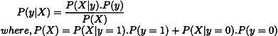

Using only the values of P(X|y) and P(y) for the particular class we can calculate P(y|X) i.e given the features of a data sample what is the probability it belongs to the class ‘y’.

Gaussian Discriminant Analysis is a Generative Learning Algorithm and in order to capture the distribution of each class, it tries to fit a Gaussian Distribution to every class of the data separately. The below images depict the difference between the Discriminative and Generative Learning Algorithms. The probability of a prediction in the case of the Generative learning algorithm will be high if it lies near the centre of the contour corresponding to its class and decreases as we move away from the centre of the contour.

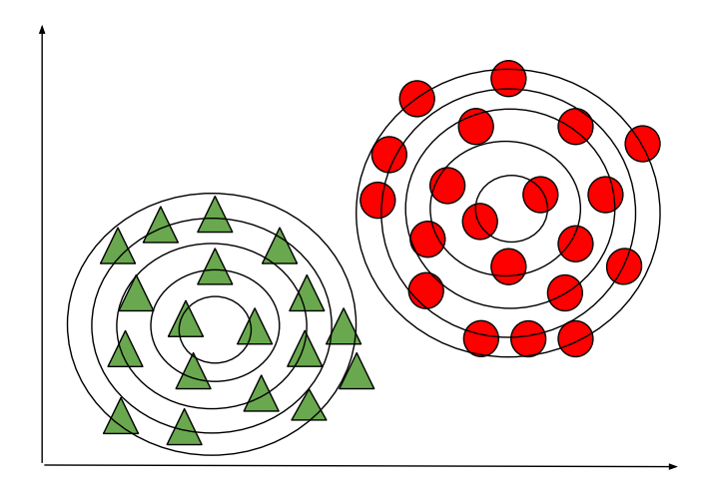
Generative Learning Algorithm (GDA)
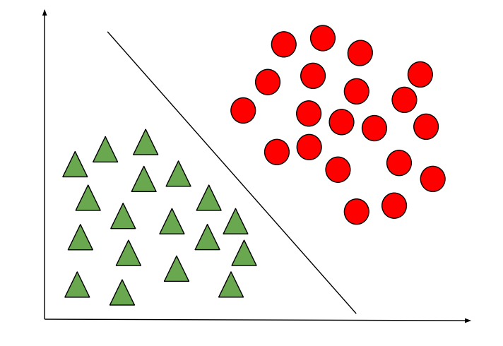
Discriminative Learning Algorithm

Let’s consider a binary classification problem such that all the data samples are IID (Independently and Identically distributed), therefore to calculate P(X|y) we can use Multivariate Gaussian Distribution to form a probability density function for each individual class. And to calculate P(y) or class prior for each class we can use Bernoulli distribution as all the data samples in binary classification can either take value 1 or 0.

Therefore, the probability distribution and class prior to a data sample can be defined using the general form of Gaussian and Bernoulli distribution respectively:

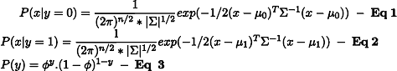[Tex]\\\\ In\hspace{1mm}the\hspace{1mm}above\hspace{1mm}equations:\\ \mu_0\hspace{1mm}is\hspace{1mm}the\hspace{1mm}mean\hspace{1mm} of\hspace{1mm} data\hspace{1mm} samples\hspace{1mm} corresponding\hspace{1mm} to\hspace{1mm} class\hspace{1mm}0\hspace{1mm}of\hspace{1mm}dimensions\hspace{1mm}\R^{n*1}\\\mu_1\hspace{1mm}is\hspace{1mm}the\hspace{1mm}mean\hspace{1mm} of\hspace{1mm} data\hspace{1mm} samples\hspace{1mm} corresponding\hspace{1mm} to\hspace{1mm} class\hspace{1mm} 1\hspace{1mm}of\hspace{1mm}dimensions\hspace{1mm}\R^{n*1}\\ \newline\Sigma\hspace{1mm}is \hspace{1mm}the \hspace{1mm}co-variance \hspace{1mm}matrix\hspace{1mm}of\hspace{1mm}dimensions\hspace{1mm}\R^{n*n}. \newline\hspace{1mm}\phi\hspace{1mm}is\hspace{1mm}the\hspace{1mm}probability\hspace{1mm}that\hspace{1mm}a\hspace{1mm}data\hspace{1mm}sample\hspace{1mm}belongs\hspace{1mm}to\hspace{1mm}class\hspace{1mm}y \newline [/Tex]

In order to view the probability distributions as a function of parameters mentioned above, we can define a Likelihood function which is equal to the product of probability distribution and class prior to each data sample (Taking product of the probabilities is reasonable as all the data samples are considered IID).

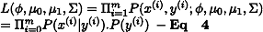

According to the principle of Maximum Likelihood estimation we have to choose the value of parameters in a way to maximize the probability function given in Eq 4. To do so instead of maximizing the Likelihood function we can maximize Log-Likelihood Function which is a strictly increasing function.

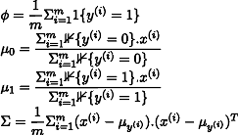

In the above equations, the function “1{condition}” is the indicator function which returns 1 if the condition is true else returns 0. For example, 1{y=1} will return 1 only when the class of that data sample is 1 else returns 0 similarly, in the case of 1{y=0} will return 1 only when the class of that data sample is 0 else it returns 0.

The values of the parameters obtained can be plugged in Eq 1, 2, and 3 to find the probability distribution and class prior to all the data samples. These values obtained can be further multiplied to find the Likelihood function given in Eq 4. As mentioned earlier the likelihood function i.e P(X|y). P(y) can be plugged into the Bayes formula to predict P(y|X) (i.e predict the class ‘y‘ of a data sample for the given features ‘X‘).

NOTE: The data samples in this model is considered to be IID which is an assumption made about the model, Gaussian Discriminant Analysis will perform poorly if the data is not a Gaussian distribution, therefore, it is always suggested visualizing the data to check if it has a normal distribution and if not attempts can be made to do so by using methods like log-transform etc. (Do not confuse Gaussian Discriminant Analysis with Gaussian Mixture model which is an unsupervised learning algorithm).

Therefore, Gaussian Discriminant Analysis works quite well for a small amount of data (say a few thousand examples) and can be more robust compared to Logistic Regression if our underlying assumptions about the distribution of the data are true

Reference: http://cs229.stanford.edu/notes2020spring/cs229-notes2.pdf

Recommended
Solve DSA problems on GfG Practice.
Solve Problems


Gaussian Discriminant Analysis
- Difficulty Level : Hard
- Last Updated : 26 Oct, 2021
- Read
- Discuss
There are two types of Supervised Learning algorithms used for classification in Machine Learning.
- Discriminative Learning Algorithms
- Generative Learning Algorithms
Discriminative Learning Algorithms include Logistic Regression, Perceptron Algorithm, etc. which try to find a decision boundary between different classes during the learning process. For example, given a classification problem to predict whether a patient has malaria or not a Discriminative Learning Algorithm will try to create a classification boundary to separate two types of patients, and when a new example is introduced it is checked on which side of the boundary the example lies to classify it. Such algorithms try to model P(y|X) i.e. given a feature set X for a data sample what is the probability it belongs to the class ‘y’.

On the other hand, Generative Learning Algorithms follow a different approach, they try to capture the distribution of each class separately instead of finding a decision boundary among classes. Considering the previous example, a Generative Learning Algorithm will look at the distribution of infected patients and healthy patients separately and try to learn each of the distribution’s features separately, when a new example is introduced it is compared to both the distributions, the class to which the data example resembles the most will be assigned to it. Such algorithms try to model P(X|y) for a given P(y) here, P(y) is known as a class prior.
The predictions for generative learning algorithms are made using Bayes Theorem as follows:

Using only the values of P(X|y) and P(y) for the particular class we can calculate P(y|X) i.e given the features of a data sample what is the probability it belongs to the class ‘y’.

Gaussian Discriminant Analysis is a Generative Learning Algorithm and in order to capture the distribution of each class, it tries to fit a Gaussian Distribution to every class of the data separately. The below images depict the difference between the Discriminative and Generative Learning Algorithms. The probability of a prediction in the case of the Generative learning algorithm will be high if it lies near the centre of the contour corresponding to its class and decreases as we move away from the centre of the contour.

Generative Learning Algorithm (GDA)
Discriminative Learning Algorithm

Let’s consider a binary classification problem such that all the data samples are IID (Independently and Identically distributed), therefore to calculate P(X|y) we can use Multivariate Gaussian Distribution to form a probability density function for each individual class. And to calculate P(y) or class prior for each class we can use Bernoulli distribution as all the data samples in binary classification can either take value 1 or 0.

Therefore, the probability distribution and class prior to a data sample can be defined using the general form of Gaussian and Bernoulli distribution respectively:

[Tex]\\\\ In\hspace{1mm}the\hspace{1mm}above\hspace{1mm}equations:\\ \mu_0\hspace{1mm}is\hspace{1mm}the\hspace{1mm}mean\hspace{1mm} of\hspace{1mm} data\hspace{1mm} samples\hspace{1mm} corresponding\hspace{1mm} to\hspace{1mm} class\hspace{1mm}0\hspace{1mm}of\hspace{1mm}dimensions\hspace{1mm}\R^{n*1}\\\mu_1\hspace{1mm}is\hspace{1mm}the\hspace{1mm}mean\hspace{1mm} of\hspace{1mm} data\hspace{1mm} samples\hspace{1mm} corresponding\hspace{1mm} to\hspace{1mm} class\hspace{1mm} 1\hspace{1mm}of\hspace{1mm}dimensions\hspace{1mm}\R^{n*1}\\ \newline\Sigma\hspace{1mm}is \hspace{1mm}the \hspace{1mm}co-variance \hspace{1mm}matrix\hspace{1mm}of\hspace{1mm}dimensions\hspace{1mm}\R^{n*n}. \newline\hspace{1mm}\phi\hspace{1mm}is\hspace{1mm}the\hspace{1mm}probability\hspace{1mm}that\hspace{1mm}a\hspace{1mm}data\hspace{1mm}sample\hspace{1mm}belongs\hspace{1mm}to\hspace{1mm}class\hspace{1mm}y \newline [/Tex]

In order to view the probability distributions as a function of parameters mentioned above, we can define a Likelihood function which is equal to the product of probability distribution and class prior to each data sample (Taking product of the probabilities is reasonable as all the data samples are considered IID).

According to the principle of Maximum Likelihood estimation we have to choose the value of parameters in a way to maximize the probability function given in Eq 4. To do so instead of maximizing the Likelihood function we can maximize Log-Likelihood Function which is a strictly increasing function.

In the above equations, the function “1{condition}” is the indicator function which returns 1 if the condition is true else returns 0. For example, 1{y=1} will return 1 only when the class of that data sample is 1 else returns 0 similarly, in the case of 1{y=0} will return 1 only when the class of that data sample is 0 else it returns 0.

The values of the parameters obtained can be plugged in Eq 1, 2, and 3 to find the probability distribution and class prior to all the data samples. These values obtained can be further multiplied to find the Likelihood function given in Eq 4. As mentioned earlier the likelihood function i.e P(X|y). P(y) can be plugged into the Bayes formula to predict P(y|X) (i.e predict the class ‘y‘ of a data sample for the given features ‘X‘).

NOTE: The data samples in this model is considered to be IID which is an assumption made about the model, Gaussian Discriminant Analysis will perform poorly if the data is not a Gaussian distribution, therefore, it is always suggested visualizing the data to check if it has a normal distribution and if not attempts can be made to do so by using methods like log-transform etc. (Do not confuse Gaussian Discriminant Analysis with Gaussian Mixture model which is an unsupervised learning algorithm).

Therefore, Gaussian Discriminant Analysis works quite well for a small amount of data (say a few thousand examples) and can be more robust compared to Logistic Regression if our underlying assumptions about the distribution of the data are true

Reference: http://cs229.stanford.edu/notes2020spring/cs229-notes2.pdf

Recommended
Solve DSA problems on GfG Practice.
Solve Problems

ML | Independent Component Analysis
- Difficulty Level : Easy
- Last Updated : 22 May, 2019
- Read
- Discuss
Prerequisite: Principal Component Analysis
Independent Component Analysis (ICA) is a machine learning technique to separate independent sources from a mixed signal. Unlike principal component analysis which focuses on maximizing the variance of the data points, the independent component analysis focuses on independence, i.e. independent components.

Problem: To extract independent sources’ signals from a mixed signal composed of the signals from those sources.
Given: Mixed signal from five different independent sources.
Aim: To decompose the mixed signal into independent sources:
- Source 1
- Source 2
- Source 3
- Source 4
- Source 5
Solution: Independent Component Analysis (ICA).

Consider Cocktail Party Problem or Blind Source Separation problem to understand the problem which is solved by independent component analysis.
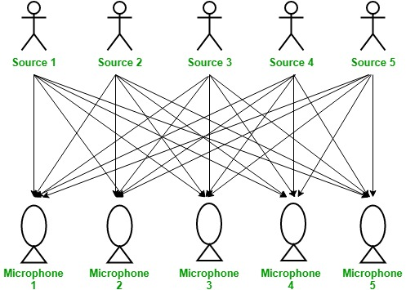
Here, There is a party going into a room full of people. There is ‘n’ number of speakers in that room and they are speaking simultaneously at the party. In the same room, there are also ‘n’ number of microphones placed at different distances from the speakers which are recording ‘n’ speakers’ voice signals. Hence, the number of speakers is equal to the number must of microphones in the room.
Now, using these microphones’ recordings, we want to separate all the ‘n’ speakers’ voice signals in the room given each microphone recorded the voice signals coming from each speaker of different intensity due to the difference in distances between them. Decomposing the mixed signal of each microphone’s recording into independent source’s speech signal can be done by using the machine learning technique, independent component analysis.
[ X1, X2, ….., Xn ] => [ Y1, Y2, ….., Yn ]
where, X1, X2, …, Xn are the original signals present in the mixed signal and Y1, Y2, …, Yn are the new features and are independent components which are independent of each other.

Restrictions on ICA –
- The independent components generated by the ICA are assumed to be statistically independent of each other.
- The independent components generated by the ICA must have non-gaussian distribution.
- The number of independent components generated by the ICA is equal to the number of observed mixtures.
Difference between PCA and ICA –
Principal Component Analysis | Independent Component Analysis
It reduces the dimensions to avoid the problem of overfitting. | It decomposes the mixed signal into its independent sources’ signals.
It deals with the Principal Components. | It deals with the Independent Components.
It focuses on maximizing the variance. | It doesn’t focus on the issue of variance among the data points.
It focuses on the mutual orthogonality property of the principal components. | It doesn’t focus on the mutual orthogonality of the components.
It doesn’t focus on the mutual independence of the components. | It focuses on the mutual independence of the components.

ML | Feature Mapping
- Difficulty Level : Medium
- Last Updated : 06 Oct, 2021
- Read
- Discuss
In data science one of the main concern is time complexity which depends largely on the number of features. In the initial years, the number of features was however not a concern. But today the amount of data and the features contributing information to them have increased exponentially. Hence it becomes necessary to find out convenient measures to reduce the number of features. Things that can be visualized can be comfortably taken a decision upon. Feature Mapping is one such process of representing features along with the relevancy of these features on a graph. This ensures that the features are visualized and their corresponding information is visually available. In this manner, the irrelevant features are excluded and only the relevant ones are included.
This article mainly focuses on how the features can be graphically represented.
A graph G = {V, E, W} is a structure formed by a collection of points or vertices V, a set of pairs of points or edges E, each pair {u, v} being represented by a line and a weight W attached to each edge E. Each feature in a dataset is considered a node of an undirected graph. Some of these features are irrelevant and need to be processed to detect their relevancy in learning, whether supervised or unsupervised. Various methods and threshold values determine the optimal feature set. In the context of feature selection, a vertex can represent a feature, an edge can represent the relationship between two features and a weight attached to an edge can represent the strength of the relationship between two features. Relation between two features is an area open for diverse approaches.

Pearson’s correlation coefficient determines the correlation between two features and hence how related they are. If two features contribute the same information then one among them is considered potentially redundant, this is because the classification would finally give the same result whether or whether not both of them are included or any one of them is included.

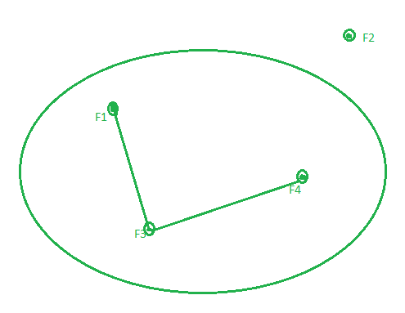
The correlation matrix of the features determines the association between various features. If two features are having an absolute value of correlation greater than 0.67 then the vertices representing those features are made adjacent by adding an edge and giving them weight equal to the correlation value. The features having association are the ones that are potentially redundant because they contribute the same information. To eliminate the redundant features from these associated features, we use the vertex cover algorithm to get the minimum vertex cover. The minimal vertex cover gives us the minimal set of optimal features which are enough to contribute the complete information which was previously contributed by all these associated features. This way we can reduce the number of features without compromising on the information content of the features.
Thus the optimal set of features are relevant with no redundancy and can contribute information to the original dataset. Reducing the number of features not only decreases the time complexity but also enhances the accuracy of the classification or clustering. This is because many times a few features in the dataset are completely redundant and divert the prediction.

Previous
ML | Principal Component Analysis(PCA)
Next
R | Simple Linear Regression
Recommended Articles
Page :
1
2
3
Parameters for Feature Selection
29, Apr 18
Python | How and where to apply Feature Scaling?
17, Jun 18
ML | Feature Scaling - Part 1
20, Jun 18
ML | Feature Scaling – Part 2
02, Jul 18
ML | Chi-square Test for feature selection
20, Dec 18
Feature Matching using Brute Force in OpenCV
09, Mar 21
Chi-Square Test for Feature Selection - Mathematical Explanation
19, Jul 19
ML | Extra Tree Classifier for Feature Selection
21, Jul 19
Pyspark | Linear regression with Advanced Feature Dataset using Apache MLlib
21, Aug 19
Feature Scaling - Part 3
22, Nov 20
Feature Selection using Branch and Bound Algorithm
24, Nov 20
Feature Selection Techniques in Machine Learning
19, Jan 21
Feature Subset Selection Process
09, Mar 21
Feature Extraction Techniques - NLP
03, Mar 20
Feature Encoding Techniques - Machine Learning
14, May 20
Sklearn | Feature Extraction with TF-IDF
20, Sep 19
Autocorrector Feature Using NLP In Python
26, Oct 22
Mapping Techniques in Artificial Intelligence and Robotics
27, May 21
Linear mapping
20, Sep 21
Simultaneous Localization and Mapping
13, Oct 21
Article Contributed By :
sagarika3kundu
@sagarika3kundu
Vote for difficulty
Current difficulty : Medium
Improved By :
- 23603vaibhav2021
Article Tags :
- Advanced Computer Subject
- Machine Learning
Practice Tags :
- Machine Learning

Report Issue
Data Structures & Algorithms- Self Paced Course
View Details
AD

AD

What's New

Machine Learning Foundation - Self Paced
View Details
Complete Interview Preparation- Self Paced Course
View Details

AD

AD

AD

ML | Extra Tree Classifier for Feature Selection
- Difficulty Level : Easy
- Last Updated : 01 Jul, 2020
- Read
- Discuss
Prerequisites: Decision Tree Classifier
Extremely Randomized Trees Classifier(Extra Trees Classifier) is a type of ensemble learning technique which aggregates the results of multiple de-correlated decision trees collected in a “forest” to output it’s classification result. In concept, it is very similar to a Random Forest Classifier and only differs from it in the manner of construction of the decision trees in the forest.

Each Decision Tree in the Extra Trees Forest is constructed from the original training sample. Then, at each test node, Each tree is provided with a random sample of k features from the feature-set from which each decision tree must select the best feature to split the data based on some mathematical criteria (typically the Gini Index). This random sample of features leads to the creation of multiple de-correlated decision trees.
To perform feature selection using the above forest structure, during the construction of the forest, for each feature, the normalized total reduction in the mathematical criteria used in the decision of feature of split (Gini Index if the Gini Index is used in the construction of the forest) is computed. This value is called the Gini Importance of the feature. To perform feature selection, each feature is ordered in descending order according to the Gini Importance of each feature and the user selects the top k features according to his/her choice.

Consider the following data:-
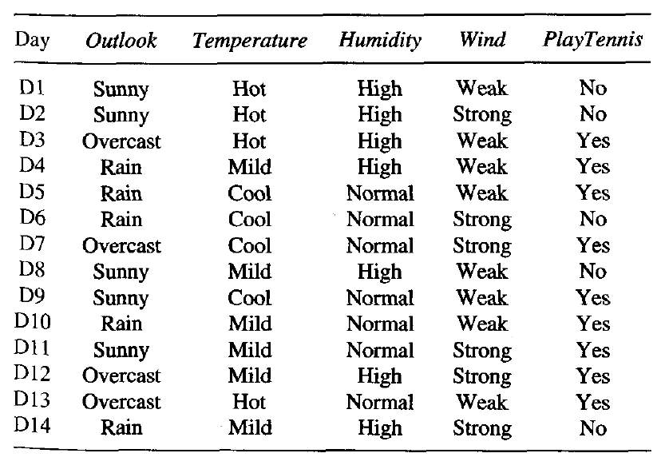
Let us build a hypothetical Extra Trees Forest for the above data with five decision trees and the value of k which decides the number of features in a random sample of features be two. Here the decision criteria used will be Information Gain. First, we calculate the entropy of the data. Note the formula for calculating the entropy is:-
where c is the number of unique class labels and is the proportion of rows with output label is i.
Therefore for the given data, the entropy is:-
Let the decision trees be constructed such that:-

- 1st Decision Tree gets data with the features Outlook and Temperature:
Note that the formula for Information Gain is:-
Thus,

Similarly:
- 2nd Decision Tree gets data with the features Temperature and Wind:
Using the above-given formulas:-

- strong>3rd Decision Tree gets data with the features Outlook and Humidity:

- 4th Decision Tree gets data with the features Temperature and Humidity:

- 5th Decision Tree gets data with the features Wind and Humidity:

Computing total Info Gain for each feature:-

Total Info Gain for Outlook = 0.246+0.246 = 0.492

Total Info Gain for Temperature = 0.029+0.029+0.029 = 0.087

Total Info Gain for Humidity = 0.151+0.151+0.151 = 0.453

Total Info Gain for Wind = 0.048+0.048 = 0.096

Thus the most important variable to determine the output label according to the above constructed Extra Trees Forest is the feature “Outlook”.

The below given code will demonstrate how to do feature selection by using Extra Trees Classifiers.
Step 1: Importing the required libraries
import pandas as pd
import numpy as np
import matplotlib.pyplot as plt
from sklearn.ensemble import ExtraTreesClassifier

Step 2: Loading and Cleaning the Data
# Changing the working location to the location of the file
cd C:\Users\Dev\Desktop\Kaggle

# Loading the data
df = pd.read_csv('data.csv')

# Separating the dependent and independent variables
y = df['Play Tennis']
X = df.drop('Play Tennis', axis = 1)

X.head()

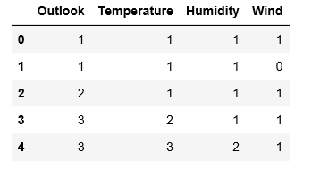
Step 3: Building the Extra Trees Forest and computing the individual feature importances
# Building the model
extra_tree_forest = ExtraTreesClassifier(n_estimators = 5,
criterion ='entropy', max_features = 2)

# Training the model
extra_tree_forest.fit(X, y)

# Computing the importance of each feature
feature_importance = extra_tree_forest.feature_importances_

# Normalizing the individual importances
feature_importance_normalized = np.std([tree.feature_importances_ for tree in
extra_tree_forest.estimators_],
axis = 0)

Step 4: Visualizing and Comparing the results
# Plotting a Bar Graph to compare the models
plt.bar(X.columns, feature_importance_normalized)
plt.xlabel('Feature Labels')
plt.ylabel('Feature Importances')
plt.title('Comparison of different Feature Importances')
plt.show()

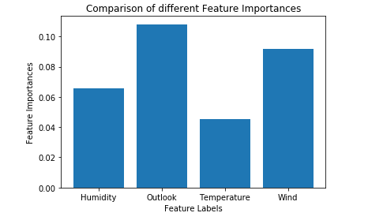
Thus the above-given output validates our theory about feature selection using Extra Trees Classifier. The importance of features might have different values because of the random nature of feature samples.

Previous
ML | Frequent Pattern Growth Algorithm
Next
Python PIL | Image.convert() Method
Recommended Articles
Page :
1
2
3
Parameters for Feature Selection
29, Apr 18
ML | Chi-square Test for feature selection
20, Dec 18
Chi-Square Test for Feature Selection - Mathematical Explanation
19, Jul 19
Feature Selection using Branch and Bound Algorithm
24, Nov 20
Feature Selection Techniques in Machine Learning
19, Jan 21
Feature Subset Selection Process
09, Mar 21
NLP | Classifier-based tagging
22, Feb 19
NLP | Classifier-based Chunking | Set 1
22, Feb 19
Ensemble Classifier | Data Mining
14, May 19
ML | Bagging classifier
16, May 19
ML | Implementation of KNN classifier using Sklearn
23, May 19
ML | Voting Classifier using Sklearn
23, Nov 19
Rule-Based Classifier - Machine Learning
06, May 20
IBM HR Analytics on Employee Attrition & Performance using Random Forest Classifier
15, Aug 20
Random Forest Classifier using Scikit-learn
04, Sep 20
Understanding Auxiliary Classifier : GAN
13, Oct 20
Hyperparameters of Random Forest Classifier
22, Jan 21
Identify Members of BTS — An Image Classifier
23, Sep 21
Face detection using Cascade Classifier using OpenCV-Python
16, Oct 21
Implementation of a CNN based Image Classifier using PyTorch
21, Feb 22
Building Naive Bayesian classifier with WEKA
05, May 21
Save classifier to disk in scikit-learn in Python
23, Jul 22
ML - Nearest Centroid Classifier
14, Jul 20
Building a Machine Learning Model Using J48 Classifier
20, Sep 21
Article Contributed By :
AlindGupta
@AlindGupta
Vote for difficulty
Current difficulty : Easy
Improved By :
- nidhi_biet
Article Tags :
- Machine Learning
- Python
Practice Tags :
- Machine Learning
- python

Report Issue
Data Structures & Algorithms- Self Paced Course
View Details
AD

AD

What's New


Python Programming Foundation -Self Paced Course
View Details
Complete Interview Preparation- Self Paced Course
View Details

AD

AD

AD

Chi-Square Test for Feature Selection – Mathematical Explanation
- Difficulty Level : Easy
- Last Updated : 26 Nov, 2019
- Read
- Discuss
One of the primary tasks involved in any supervised Machine Learning venture is to select the best features from the given dataset to obtain the best results. One way to select these features is the Chi-Square Test.
Mathematically, a Chi-Square test is done on two distributions two determine the level of similarity of their respective variances. In its null hypothesis, it assumes that the given distributions are independent. This test thus can be used to determine the best features for a given dataset by determining the features on which the output class label is most dependent on. For each feature in the dataset, the is calculated and then ordered in descending order according to the value. The higher the value of , the more dependent the output label is on the feature and higher the importance the feature has on determining the output.

Let the feature in question have m attribute values and the output have k class labels. Then the value of is given by the following expression:-
where

– Observed frequency
– Expected frequency
For each feature, a contingency table is created with m rows and k columns. Each cell (i,j) denotes the number of rows having attribute feature as i and class label as k. Thus each cell in this table denotes the observed frequency. To calculate the expected frequency for each cell, first the proportion of the feature value in the total dataset is calculated and then it is multiplied by the total number of the current class label.
Solved Example:
Consider the following table:-
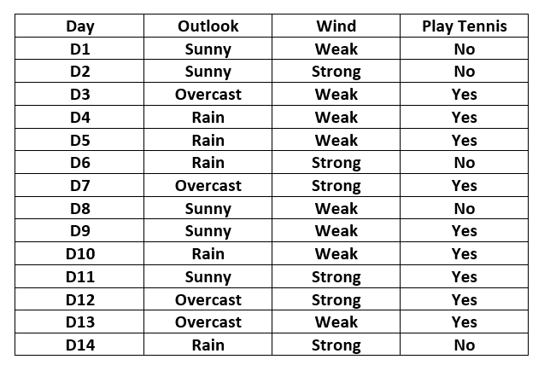
Here the output variable is the column named “PlayTennis” which determines whether tennis was played on the given day given the weather conditions.
The contingency table for the feature “Outlook” is constructed as below:-
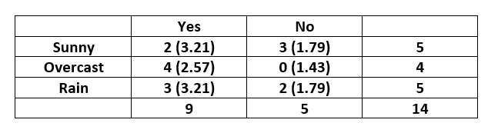

Note that the expected value for each cell is given inside the parenthesis.
The expected value for the cell (Sunny,Yes) is calculated as and similarly for others.
The value is calculated as below:-
The contingency table for the feature “Wind” is constructed as below:-
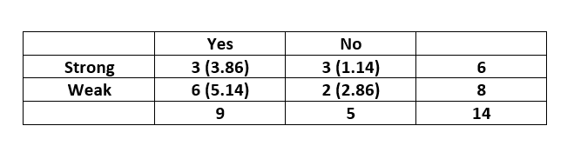
The value is calculated as below:-
On comparing the two scores, we can conclude that the feature “Wind” is more important to determine the output than the feature “Outlook”.
This article demonstrates how to do feature selection using Chi-Square Test.

Previous
ML | Chi-square Test for feature selection
Next
Python - Swap elements in String list
Recommended Articles
Page :
1
2
3
numpy.random.chisquare() in Python
03, Jul 20
ML | Chi-square Test for feature selection
20, Dec 18
Mathematical explanation of K-Nearest Neighbour
20, Jan 21
ML | Mathematical explanation of RMSE and R-squared error
01, Aug 19
Mathematical explanation for Linear Regression working
21, Sep 18
Parameters for Feature Selection
29, Apr 18
ML | Extra Tree Classifier for Feature Selection
21, Jul 19
Feature Selection using Branch and Bound Algorithm
24, Nov 20
Feature Selection Techniques in Machine Learning
19, Jan 21
Feature Subset Selection Process
09, Mar 21
Explanation of Fundamental Functions involved in A3C algorithm
21, Jun 19
Recurrent Neural Networks Explanation
09, Jul 19
Long Short Term Memory Networks Explanation
09, Jul 19
ML | OPTICS Clustering Explanation
12, Jul 19
Django settings file - step by step Explanation
19, Jul 20
Explanation of BERT Model - NLP
30, Apr 20
Mathematical Functions in Python | Set 3 (Trigonometric and Angular Functions)
28, Jul 16
Mathematical Functions in Python | Set 4 (Special Functions and Constants)
29, Jul 16
Q-learning Mathematical Background
13, Jun 19
Python | Mathematical Median of Cumulative Records
14, Jan 20
Evaluate the Mathematical Expressions using Tkinter in Python
25, Jul 20
Mathematical understanding of RNN and its variants
20, Jan 21
Mathematical Foundations in Tensorflow
26, Mar 22
Plot Mathematical Expressions in Python using Matplotlib
30, Mar 20
Article Contributed By :
AlindGupta
@AlindGupta
Vote for difficulty
Current difficulty : Easy
Improved By :
- ManasChhabra2
Article Tags :
- Machine Learning
- Python
Practice Tags :
- Machine Learning
- python

Report Issue
Data Structures & Algorithms- Self Paced Course
View Details
AD

AD

What's New

Python Programming Foundation -Self Paced Course
View Details
Complete Interview Preparation- Self Paced Course
View Details

AD

AD

AD

ML | T-distributed Stochastic Neighbor Embedding (t-SNE) Algorithm
- Last Updated : 04 Nov, 2022
- Read
- Discuss
T-distributed Stochastic Neighbor Embedding (t-SNE) is a nonlinear dimensionality reduction technique well-suited for embedding high-dimensional data for visualization in a low-dimensional space of two or three dimensions.
What is Dimensionality Reduction?
Dimensionality Reduction is the technique of representing n-dimensions data(multidimensional data with many features) in 2 or 3 dimensions.
An example of dimensionality reduction can be discussed as a classification problem i.e. student will play football or not that relies on both temperature and humidity can be collapsed into just one underlying feature, since both of the features are correlated to a high degree. Hence, we can reduce the number of features in such problems. A 3-D classification problem can be hard to visualize, whereas a 2-D one can be mapped to simple 2-dimensional space and a 1-D problem to a simple line.

How does t-SNE works?
t-SNE a non-linear dimensionality reduction algorithm finds patterns in the data based on the similarity of data points with features, the similarity of points is calculated as the conditional probability that a point A would choose point B as its neighbour.
It then tries to minimize the difference between these conditional probabilities (or similarities) in higher-dimensional and lower-dimensional space for a perfect representation of data points in lower-dimensional space.
Space and Time Complexity:
The algorithm computes pairwise conditional probabilities and tries to minimize the sum of the difference of the probabilities in higher and lower dimensions. This involves a lot of calculations and computations. So the algorithm takes a lot of time and space to compute. t-SNE has a quadratic time and space complexity in the number of data points.

Code: Python code implementing T-SNE on MNIST dataset

# Importing Necessary Modules.
import numpy as np
import pandas as pd
import matplotlib.pyplot as plt
from sklearn.manifold import TSNE
from sklearn.preprocessing import StandardScaler

Code #1: Reading data

# Reading the data using pandas
df = pd.read_csv('mnist_train.csv')

# print first five rows of df
print(df.head(4))

# save the labels into a variable l.
l = df['label']

# Drop the label feature and store the pixel data in d.
d = df.drop("label", axis = 1)

Output:
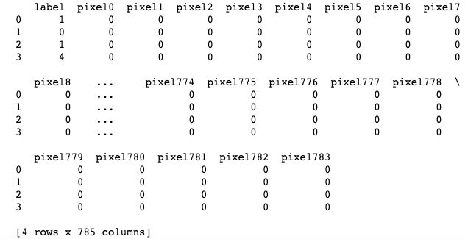
Code #2: Data-preprocessing

# Data-preprocessing: Standardizing the data
from sklearn.preprocessing import StandardScaler

standardized_data = StandardScaler().fit_transform(data)
print(standardized_data.shape)

Output:

(15000, 784)
Code #3:

# TSNE
# Picking the top 1000 points as TSNE
# takes a lot of time for 15K points
data_1000 = standardized_data[0:1000, :]
labels_1000 = labels[0:1000]

model = TSNE(n_components = 2, random_state = 0)
# configuring the parameters
# the number of components = 2
# default perplexity = 30
# default learning rate = 200
# default Maximum number of iterations
# for the optimization = 1000

tsne_data = model.fit_transform(data_1000)

# creating a new data frame which
# help us in plotting the result data
tsne_data = np.vstack((tsne_data.T, labels_1000)).T
tsne_df = pd.DataFrame(data = tsne_data,
columns =("Dim_1", "Dim_2", "label"))

# Plotting the result of tsne
sn.FacetGrid(tsne_df, hue ="label", size = 6).map(
plt.scatter, 'Dim_1', 'Dim_2').add_legend()

plt.show()

Output:
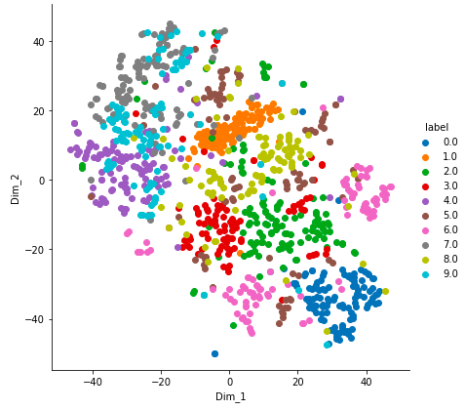

Previous
Python | Transcribing dictionary key
Next
Python | Split K elements after every N values
Recommended Articles
Page :
1
2
3
k-nearest neighbor algorithm in Python
09, Apr 19
Stochastic Games in Artificial Intelligence
26, Feb 22
ML | Stochastic Gradient Descent (SGD)
15, Feb 19
Difference between Batch Gradient Descent and Stochastic Gradient Descent
12, Jun 20
Overview of Word Embedding using Embeddings from Language Models (ELMo)
16, Mar 21
Word Embedding using Universal Sentence Encoder in Python
25, Mar 21
Pre-trained Word embedding using Glove in NLP models
18, Feb 22
Python | Word Embedding using Word2Vec
18, May 18
Different Types of Clustering Algorithm
15, Jan 18
Simple Genetic Algorithm (SGA)
01, Apr 21
Asynchronous Advantage Actor Critic (A3C) algorithm
17, Jun 19
Cristian's Algorithm
08, Nov 18
Facebook News Feed Algorithm
04, Dec 18
Python | Foreground Extraction in an Image using Grabcut Algorithm
28, Dec 18
Implementation of Whale Optimization Algorithm
18, Jul 21
ML | Mini Batch K-means clustering algorithm
10, May 19
ML | Expectation-Maximization Algorithm
14, May 19
ML | Reinforcement Learning Algorithm : Python Implementation using Q-learning
30, May 19
Genetic Algorithm for Reinforcement Learning : Python implementation
31, May 19
Silhouette Algorithm to determine the optimal value of k
04, Jun 19
Implementing DBSCAN algorithm using Sklearn
06, Jun 19
ML | ECLAT Algorithm
11, Jun 19
Encoding Methods in Genetic Algorithm
17, Jun 19
Explanation of Fundamental Functions involved in A3C algorithm
21, Jun 19
Article Contributed By :
mohdsaquib1
@mohdsaquib1
Vote for difficulty
Improved By :
- adnanirshad158
- niharikatanwar61
- simmytarika5
Article Tags :
- Machine Learning
- Python
Practice Tags :
- Machine Learning
- python

Report Issue

Python | How and where to apply Feature Scaling?
- Difficulty Level : Medium
- Last Updated : 27 Sep, 2021
- Read
- Discuss
Feature Scaling or Standardization: It is a step of Data Pre Processing that is applied to independent variables or features of data. It basically helps to normalize the data within a particular range. Sometimes, it also helps in speeding up the calculations in an algorithm.
Package Used:

sklearn.preprocessing
Import:
from sklearn.preprocessing import StandardScaler
The formula used in Backend
Standardization replaces the values with their Z scores.

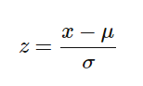
Mostly the Fit method is used for Feature scaling
fit(X, y = None)
Computes the mean and std to be used for later scaling.

import pandas as pd
from sklearn.preprocessing import StandardScaler

# Read Data from CSV
data = read_csv('Geeksforgeeks.csv')
data.head()

# Initialise the Scaler
scaler = StandardScaler()

# To scale data
scaler.fit(data)

Why and Where to Apply Feature Scaling?
The real-world dataset contains features that highly vary in magnitudes, units, and range. Normalization should be performed when the scale of a feature is irrelevant or misleading and not should Normalise when the scale is meaningful.
The algorithms which use Euclidean Distance measures are sensitive to Magnitudes. Here feature scaling helps to weigh all the features equally.
Formally, If a feature in the dataset is big in scale compared to others then in algorithms where Euclidean distance is measured this big scaled feature becomes dominating and needs to be normalized.
Examples of Algorithms where Feature Scaling matters
1. K-Means uses the Euclidean distance measure here feature scaling matters.
2. K-Nearest-Neighbours also require feature scaling.
3. Principal Component Analysis (PCA): Tries to get the feature with maximum variance, here too feature scaling is required.
4. Gradient Descent: Calculation speed increase as Theta calculation becomes faster after feature scaling.
Note: Naive Bayes, Linear Discriminant Analysis, and Tree-Based models are not affected by feature scaling.
In Short, any Algorithm which is Not Distance-based is Not affected by Feature Scaling.

Previous
ML | Feature Scaling - Part 1
Next
Overview of Scaling: Vertical And Horizontal Scaling
Recommended Articles
Page :
1
2
3
Overview of Scaling: Vertical And Horizontal Scaling
31, Jul 20
ML | Feature Scaling - Part 1
20, Jun 18
ML | Feature Scaling – Part 2
02, Jul 18
Feature Scaling - Part 3
22, Nov 20
Apply a function to each row or column in Dataframe using pandas.apply()
01, Jul 20
Image Processing in Python (Scaling, Rotating, Shifting and Edge Detection)
07, Sep 18
Python - Scaling numbers column by column with Pandas
23, Feb 21
Python - Scaling image using pgmagick
24, Apr 20
Feature detection and matching with OpenCV-Python
25, Nov 21
PyQtGraph – Getting Scaling of Error Bar Graph
15, Oct 20
PyQtGraph – Scaling Error Bar Graph
12, Oct 20
Scaling techniques in Machine Learning
13, Jul 21
Feature matching using ORB algorithm in Python-OpenCV
22, Apr 20
How to use the Live Coding Feature of Python in Eclipse?
03, Jun 21
Autocorrector Feature Using NLP In Python
26, Oct 22
Feature Selection using Branch and Bound Algorithm
24, Nov 20
Parameters for Feature Selection
29, Apr 18
ML | Feature Mapping
10, Jul 18
ML | Chi-square Test for feature selection
20, Dec 18
Feature Matching using Brute Force in OpenCV
09, Mar 21
Chi-Square Test for Feature Selection - Mathematical Explanation
19, Jul 19
ML | Extra Tree Classifier for Feature Selection
21, Jul 19
Pyspark | Linear regression with Advanced Feature Dataset using Apache MLlib
21, Aug 19
PyQt5 QDockWidget – Getting Feature change signal
17, Jul 20
Article Contributed By :

shaurya uppal
@shaurya uppal
Vote for difficulty
Current difficulty : Medium
Improved By :
- Akanksha_Rai
- marcosarcticseal
Article Tags :
- Advanced Computer Subject
- Machine Learning
- Python
Practice Tags :
- Machine Learning
- python

Report Issue
Data Structures & Algorithms- Self Paced Course
View Details
AD

AD

What's New

Python Programming Foundation -Self Paced Course
View Details
Complete Interview Preparation- Self Paced Course
View Details

AD

AD

AD

Parameters for Feature Selection
- Difficulty Level : Expert
- Last Updated : 29 Apr, 2018
- Read
- Discuss
Prerequisite : Introduction to Dimensionality Reduction
Dimensionality reduction is the process of reducing the number of random variables under consideration, by obtaining a set of principal variables. It can be divided into feature selection and feature extraction.

Dimensionality Reduction is an important factor in predictive modeling. Various proposed methods have introduced different approaches to do so by either graphically or by various other methods like filtering, wrapping or embedding. However, most of these approaches are based on some threshold values and benchmark algorithms that determine the optimality of the features in the dataset.
One motivation for dimensionality reduction is that higher dimensional data sets increase the time complexity and also the space required will be more. Also, all the features in the dataset might not be useful. Some may contribute no information at all, while some may contribute similar information as the other features. Selecting the optimal set of features will help us hence reduce the space and time complexity as well as increase the accuracy or purity of classification (or regression) and clustering (or association) for supervised and unsupervised learning respectively.

Feature selection has four different approaches such as filter approach, wrapper approach, embedded approach, and hybrid approach.
- Wrapper approach : This approach has high computational complexity. It uses a learning algorithm to evaluate the accuracy produced by the use of the selected features in classification. Wrapper methods can give high classification accuracy for particular classifiers.
- Filter approach : A subset of features is selected by this approach without using any learning algorithm. Higher-dimensional datasets use this method and it is relatively faster than the wrapper-based approaches.
- Embedded approach : The applied learning algorithms determine the specificity of this approach and it selects the features during the process of training the data set.
- Hybrid approach : Both filter and wrapper-based methods are used in hybrid approach. This approach first selects the possible optimal feature set which is further tested by the wrapper approach. It hence uses the advantages of both filter and wrapper-based approach.

Parameters For Feature Selection :
The parameters are classified based on two factors –
The Similarity of information contributed by the features :
1. CORRELATION
The features are classified as associated or similar mostly based on their correlation factor. In the data set, we have many features which are correlated. Now the problem with having correlated features is that, if f1 and f2 are two correlated features of a data set, then the classifying or regression model including both f1 and f2 will give the same as the predictive model compared to the scenario where either f1 or f2 was included in the dataset. This is because both f1 and f2 are correlated and hence they contribute the same information regarding the model in the data set. There are various methods to calculate the correlation factor, however, Pearson’s correlation coefficient is most widely used. The formula for Pearson’s correlation coefficient() is:
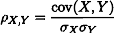

where
cov(X, Y) - covariance
sigma(X) - standard deviation of X
sigma(Y) - standard deviation of Y
Thus, the correlated features are irrelevant, as they all contribute similar information. Only one representative of the whole correlated or associated features would give the same classification or regression outcome. Hence these features are redundant and excluded for dimensionality reduction purposes after selecting a particular representative from each associated or correlated group of features using various algorithms.
Quantum of information contributed by the features :
1. ENTROPY
Entropy is the measure of the average information content. The higher the entropy, the higher is the information contribution by that feature. Entropy (H) can be formulated as:
where
X - discrete random variable X
P(X) - probability mass function
E - expected value operator,
I - information content of X.
I(X) - a random variable.
In Data Science, entropy of a feature f1 is calculated by excluding feature f1 and then calculating the entropy of the rest of the features. Now, the lower the entropy value (excluding f1) the higher will be the information content of f1. In this manner the entropy of all the features is calculated. At the end, either a threshold value or further relevancy check determines the optimality of the features on the basis of which features are selected. Entropy is mostly used for Unsupervised Learning as we do have a class field in the dataset and hence entropy of the features can give substantial information.
2. MUTUAL INFORMATION
In information theory, mutual information I(X;Y) is the amount of uncertainty in X due to the knowledge of Y. Mathematically, mutual information is defined as
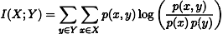
where
p(x, y) - joint probability function of X and Y,
p(x) - marginal probability distribution function of X
p(y) - marginal probability distribution function of Y
Mutual Information in Data science is mostly calculated to know the amount of information shared about the class by a feature. Hence is mostly used for dimensionality reduction in Supervised Learning. The features which have high mutual information value corresponding to the class in a supervised learning are considered optimal since they can influence the predictive model towards the right prediction and hence increase the accuracy of the model.
Reference : http://www.cs.uccs.edu/~jkalita/papers/2014/HoqueExpertSystems2014.pdf

Previous
Identifying handwritten digits using Logistic Regression in PyTorch
Next
Introduction to Dimensionality Reduction
Recommended Articles
Page :
1
2
3
ML | Chi-square Test for feature selection
20, Dec 18
Chi-Square Test for Feature Selection - Mathematical Explanation
19, Jul 19
ML | Extra Tree Classifier for Feature Selection
21, Jul 19
Feature Selection using Branch and Bound Algorithm
24, Nov 20
Feature Selection Techniques in Machine Learning
19, Jan 21
Feature Subset Selection Process
09, Mar 21
ML | Feature Mapping
10, Jul 18
Python | How and where to apply Feature Scaling?
17, Jun 18
ML | Feature Scaling - Part 1
20, Jun 18
ML | Feature Scaling – Part 2
02, Jul 18
Feature Matching using Brute Force in OpenCV
09, Mar 21
Pyspark | Linear regression with Advanced Feature Dataset using Apache MLlib
21, Aug 19
Feature Scaling - Part 3
22, Nov 20
Feature Extraction Techniques - NLP
03, Mar 20
Feature Encoding Techniques - Machine Learning
14, May 20
Sklearn | Feature Extraction with TF-IDF
20, Sep 19
Autocorrector Feature Using NLP In Python
26, Oct 22
ML | One Hot Encoding to treat Categorical data parameters
12, Jun 19
Difference Between Model Parameters VS HyperParameters
11, May 20
Selection and Social Influence-Homophily in Social Networks
27, Aug 20
Article Contributed By :
sagarika3kundu
@sagarika3kundu
Vote for difficulty
Current difficulty : Expert
Article Tags :
- Advanced Computer Subject
- Machine Learning
- Technical Scripter
Practice Tags :
- Machine Learning

Report Issue

ML | Underfitting and Overfitting
- Difficulty Level : Medium
- Last Updated : 22 Aug, 2022
- Read
- Discuss
When we talk about the Machine Learning model, we actually talk about how well it performs and its accuracy which is known as prediction errors. Let us consider that we are designing a machine learning model. A model is said to be a good machine learning model if it generalizes any new input data from the problem domain in a proper way. This helps us to make predictions about future data, that the data model has never seen. Now, suppose we want to check how well our machine learning model learns and generalizes to the new data. For that, we have overfitting and underfitting, which are majorly responsible for the poor performances of the machine learning algorithms.
Before diving further let’s understand two important terms:
- Bias: Assumptions made by a model to make a function easier to learn. It is actually the error rate of the training data. When the error rate has a high value, we call it High Bias and when the error rate has a low value, we call it low Bias.
- Variance: The difference between the error rate of training data and testing data is called variance. If the difference is high then it’s called high variance and when the difference of errors is low then it’s called low variance. Usually, we want to make a low variance for generalized our model.
Underfitting: A statistical model or a machine learning algorithm is said to have underfitting when it cannot capture the underlying trend of the data, i.e., it only performs well on training data but performs poorly on testing data. (It’s just like trying to fit undersized pants!) Underfitting destroys the accuracy of our machine learning model. Its occurrence simply means that our model or the algorithm does not fit the data well enough. It usually happens when we have fewer data to build an accurate model and also when we try to build a linear model with fewer non-linear data. In such cases, the rules of the machine learning model are too easy and flexible to be applied to such minimal data and therefore the model will probably make a lot of wrong predictions. Underfitting can be avoided by using more data and also reducing the features by feature selection.
In a nutshell, Underfitting refers to a model that can neither performs well on the training data nor generalize to new data.
Reasons for Underfitting:
- High bias and low variance
- The size of the training dataset used is not enough.
- The model is too simple.
- Training data is not cleaned and also contains noise in it.
Techniques to reduce underfitting:
- Increase model complexity
- Increase the number of features, performing feature engineering
- Remove noise from the data.
- Increase the number of epochs or increase the duration of training to get better results.
Overfitting: A statistical model is said to be overfitted when the model does not make accurate predictions on testing data. When a model gets trained with so much data, it starts learning from the noise and inaccurate data entries in our data set. And when testing with test data results in High variance. Then the model does not categorize the data correctly, because of too many details and noise. The causes of overfitting are the non-parametric and non-linear methods because these types of machine learning algorithms have more freedom in building the model based on the dataset and therefore they can really build unrealistic models. A solution to avoid overfitting is using a linear algorithm if we have linear data or using the parameters like the maximal depth if we are using decision trees.
In a nutshell, Overfitting is a problem where the evaluation of machine learning algorithms on training data is different from unseen data.

Reasons for Overfitting are as follows:
- High variance and low bias
- The model is too complex
- The size of the training data
Examples:
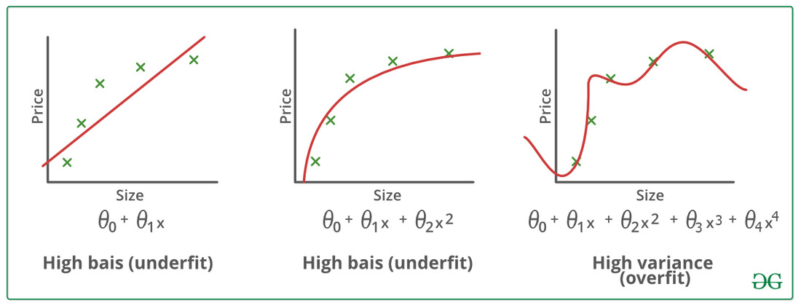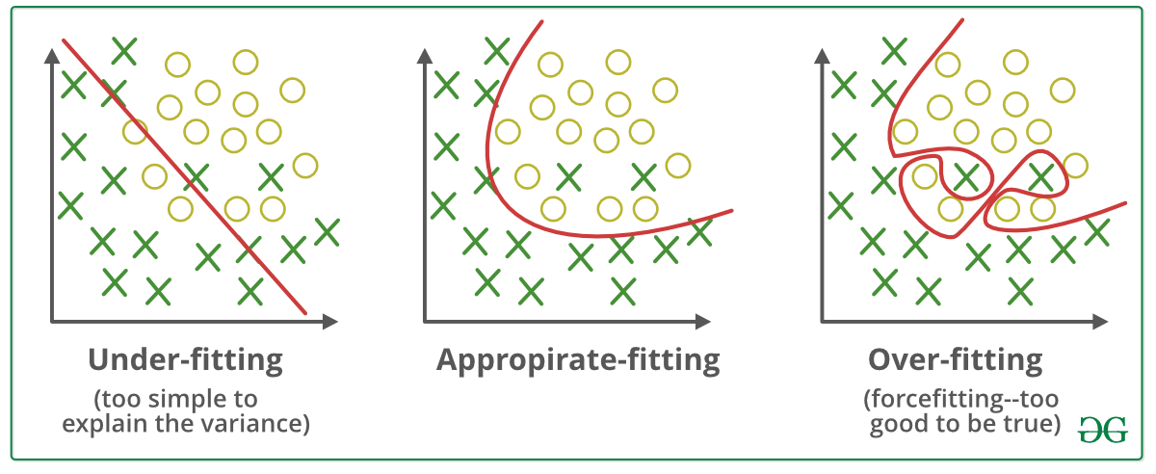
Techniques to reduce overfitting:
- Increase training data.
- Reduce model complexity.
- Early stopping during the training phase (have an eye over the loss over the training period as soon as loss begins to increase stop training).
- Ridge Regularization and Lasso Regularization
- Use dropout for neural networks to tackle overfitting.
Good Fit in a Statistical Model: Ideally, the case when the model makes the predictions with 0 error, is said to have a good fit on the data. This situation is achievable at a spot between overfitting and underfitting. In order to understand it, we will have to look at the performance of our model with the passage of time, while it is learning from the training dataset.
With the passage of time, our model will keep on learning, and thus the error for the model on the training and testing data will keep on decreasing. If it will learn for too long, the model will become more prone to overfitting due to the presence of noise and less useful details. Hence the performance of our model will decrease. In order to get a good fit, we will stop at a point just before where the error starts increasing. At this point, the model is said to have good skills in training datasets as well as our unseen testing dataset.

Next
ML | Handling Missing Values
Recommended Articles
Page :
1
2
3
How to Solve Overfitting in Random Forest in Python Sklearn?
16, Sep 22
Need of Data Structures and Algorithms for Deep Learning and Machine Learning
14, Oct 20
Black and white image colorization with OpenCV and Deep Learning
05, Mar 22
MongoDB AND operator ( $and )
09, Apr 20
Interquartile Range and Quartile Deviation using NumPy and SciPy
13, Jun 19
Basic SQL Injection and Mitigation with Example
28, Mar 17
Denial of Service and Prevention
22, Apr 17
Format String Vulnerability and Prevention with Example
23, Apr 17
Code Injection and Mitigation with Example
24, Apr 17
Path Traversal Attack and Prevention
25, Apr 17
Fuzzy Logic | Set 2 (Classical and Fuzzy Sets)
11, Apr 18
Hyperparameter tuning using GridSearchCV and KerasClassifier
25, Nov 20
Python | How and where to apply Feature Scaling?
17, Jun 18
Difference between Supervised and Unsupervised Learning
19, Jun 18
Introduction to Signals and Systems: Properties of systems
05, Mar 19
Python | Tensorflow nn.relu() and nn.leaky_relu()
13, Sep 18
Redundancy and Correlation in Data Mining
13, Jun 19
Audio processing using Pydub and Google speechRecognition API
10, Jan 19
Box plot and Histogram exploration on Iris data
18, Jan 19
NLP | Training a tokenizer and filtering stopwords in a sentence
28, Jan 19
NLP | Splitting and Merging Chunks
28, Jan 19
Build, Test and Deploy a Flask REST API Application from GitHub using Jenkins Pipeline Running on Docker
19, Sep 21
NLP | Regex and Affix tagging
21, Feb 19
Deep Neural net with forward and back propagation from scratch - Python
07, Jun 20
Article Contributed By :

dewangNautiyal
@dewangNautiyal
Vote for difficulty
Current difficulty : Medium
Improved By :
- hutah
- faridsharaf
- sheetal18june
- vijaysahm14x
Article Tags :
- Advanced Computer Subject
- Machine Learning
Practice Tags :
- Machine Learning

Report Issue
Data Structures & Algorithms- Self Paced Course
View Details
AD

AD

What's New

Machine Learning Foundation - Self Paced
View Details
Complete Interview Preparation- Self Paced Course
View Details

AD

AD

AD

